CONFIGURING OSPF

Q1. Using Cisco Packet Tracer, create a network topology with three routers in two OSPF areas (Area 0 and Area 1), and assign appropriate IP addresses to all interfaces.
Ans. In this topology I have configured both area 1 and area 0 and assigned appropeiate IP addresses to all interface.
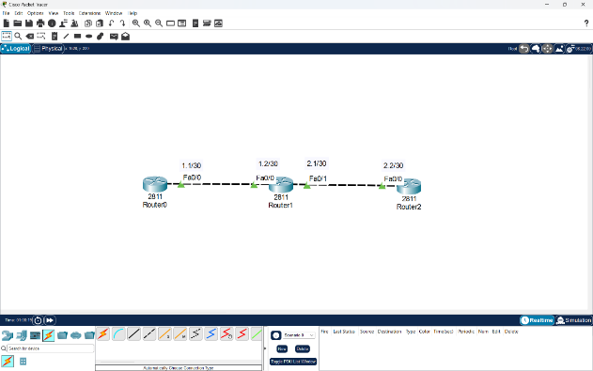
Q2. Configure OSPF on each router in your topology so that Area 0 acts as the backbone and Area 1 connects through one of the routers; verify OSPF neighbor relationships using the 'show ip ospf neighbor' command.
Ans.
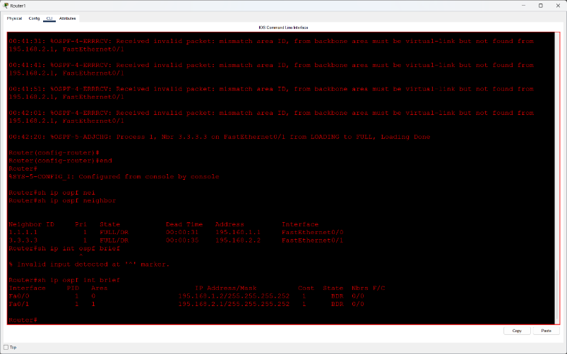
Observation
- Area 0 is configured on interface Fa0/0 as the backbone.
- Area 1 is configured on interface Fa0/1.
- The router acts as an Area Border Router (ABR) connecting both areas.
- Two OSPF neighbors are in the FULL/DR state, confirming successful adjacency.
- Initial area mismatch errors were observed, but the displayed neighbor relationships are now fully established.
Conclusion: The output confirms that Area 0 and Area 1 are configured on the router, and both OSPF neighbor adjacencies have reached the FULL/DR state.

Q3. Add two PCs to different areas in your OSPF network, assign them IP addresses, and test connectivity by pinging from one PC to the other.
Ans. I have added two PCs to different areas in my OSPF network and assigned them IP addresses also I have checked the connectivity using Ping command.
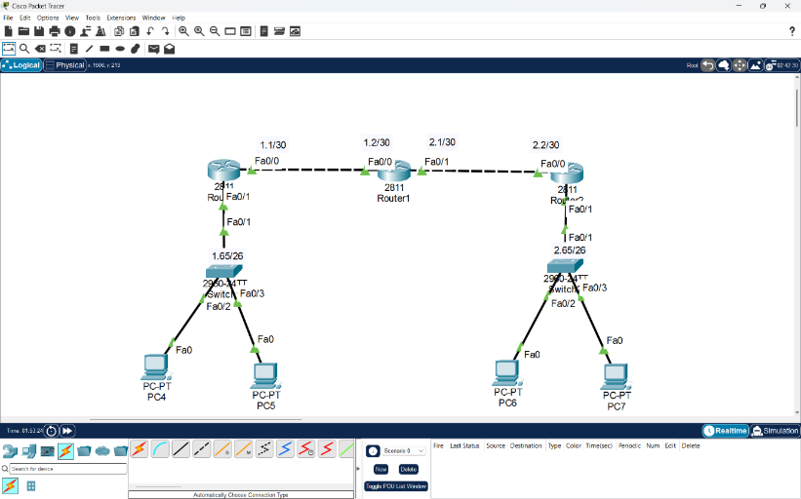
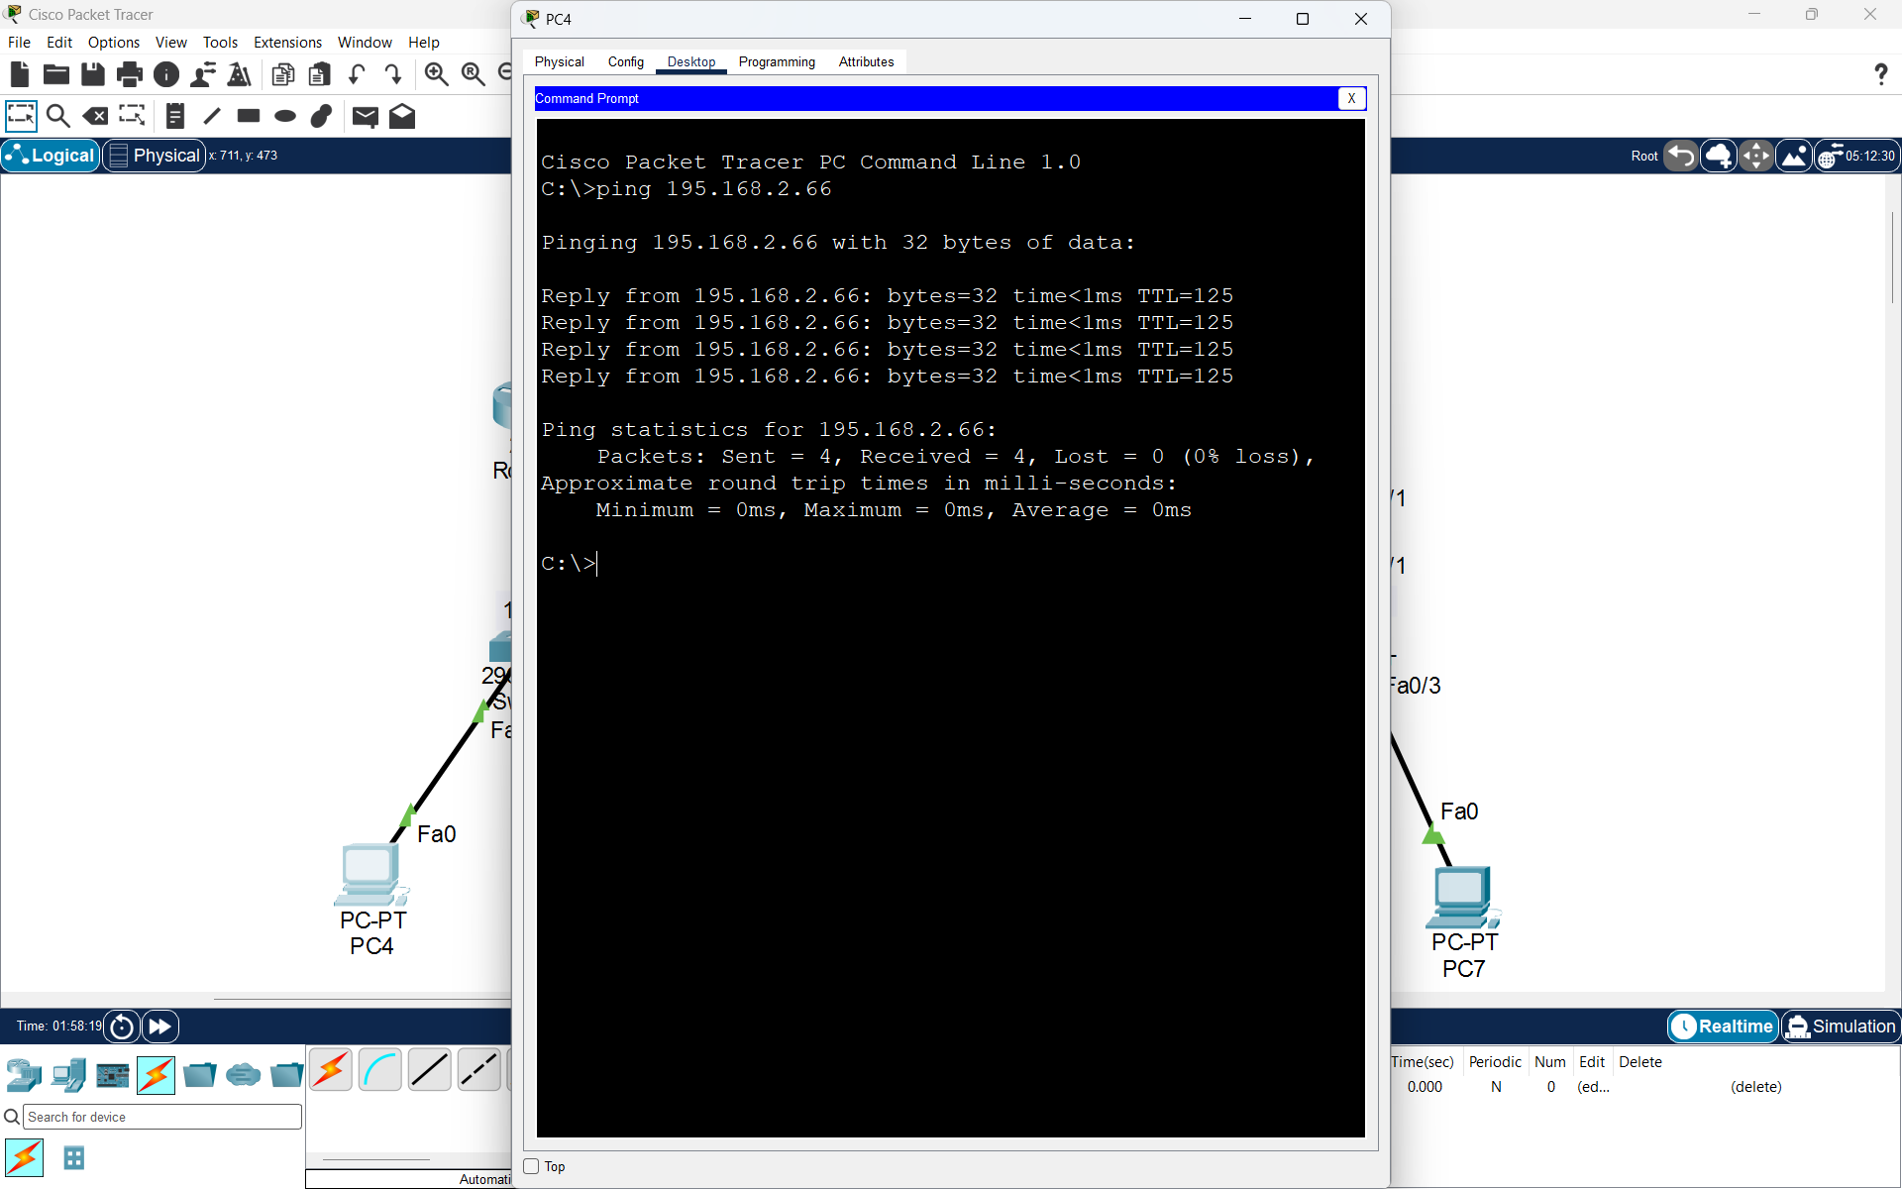
Q4. Simulate a router failure by shutting down the interface connecting Area 1 to Area 0, then use 'show ip route' and 'show ip ospf' commands to observe how OSPF reconverges and restores connectivity after re-enabling the interface. Hint: Track the time it takes for OSPF to update the routing tables after the failure and recovery.
Ans. Objective: To simulate a network failure by shutting down an interface and observe how OSPF restores connectivity.
Step 1: Check OSPF Status
Before shutting down the interface, verify OSPF routes and neighbors.
Router# show ip route
Router# show ip ospf
Router# show ip ospf neighbor
Step 2: Simulate Interface Failure
Shut down interface Fa0/1, which connects Area 1 to the backbone through the ABR.
Router# configure terminal
Router(config)# interface fa0/1
Router(config-if)# shutdown
Router(config-if)# end
Step 3: Observe OSPF Reconvergence
Router# show ip route
Router# show ip ospf
Router# show ip ospf neighbor
Observations:
- The OSPF neighbor connected through Fa0/1 becomes unavailable.
- Routes affected by the failed link are removed or recalculated.
- OSPF selects an alternative path if one is available.
Step 4: Restore Connectivity
Router# configure terminal
Router(config)# interface fa0/1
Router(config-if)# no shutdown
Router(config-if)# end
Router# show ip ospf neighbor
Router# show ip route
After recovery, OSPF neighbors should return to the FULL state, and the affected routes should be restored.
Step 5: Record Reconvergence Time
Measure the time from interface shutdown until routes update, and from re-enabling until routes are restored.
- Failure convergence time: Record observed seconds.
- Recovery convergence time: Record observed seconds.
Conclusion: OSPF automatically detects interface failures, recalculates routes, and restores connectivity after the interface is re-enabled. This demonstrates OSPF's dynamic routing and reconvergence capabilities.

